

|  |  |  |  |  |  |  |  |  |
| --- | --- | --- | --- | --- | --- | --- | --- | --- |
|  | | | | | | | | |
|  | | Group Project Proposal & Draft Object Model | | | | |  | |
|  |  | | | | | | |  |
|  | | | | See the source image |  | | | |
|  | | | |  |  | | | |
|  | | | | November 14th, 2021—ISM 6106 RG7 – System Analysis—Dr. Arijit Sengupta —  Group Four |  | | | |
|  | | |  | | |  | | |

##### Team Composition:

|  |  |
| --- | --- |
|  |  |
|  |  |
|  |  |

**Web Creation Platform**

**DRAFT UML Object Model {Jose, Laz, Osahon}:**

Figure

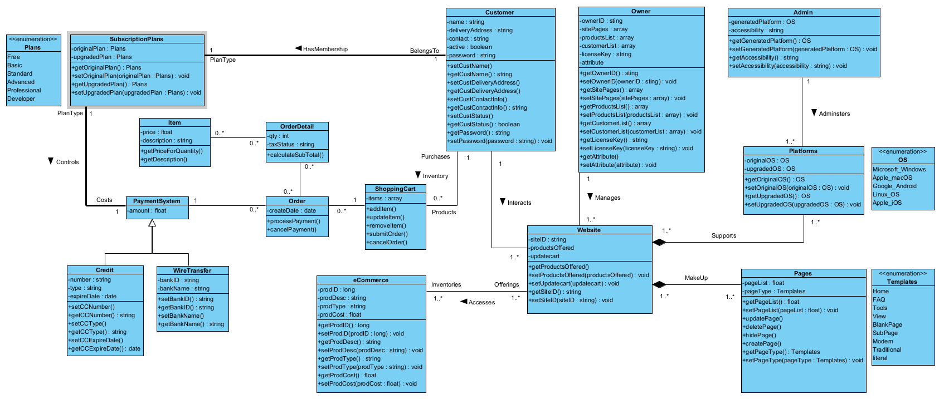

Figure

**Business Problem {Elena & Corey}:**

Team Breakfast Club has been chartered to design an application for Web Creation Platform project that allows customers to build their own website using a subscription-based platform like Wix.

**Value Proposition {Elena & Corey}:**

The user is a business owner who wants to build a website for his/her business. Our application gives the user the ability to build their own website using a pre-designed structure from various templates, choose number of pages and customize ecommerce module to his/her business needs. Building a website consists of several steps, including registration. Then the user can change any properties of his/her website, using the same software modules and user interfaces that he/she used when building website. The user can perform two operations - change the properties of the website and its modules and make financial operations. The user is charged a subscription fee for using the website.

Subscription Plans include:

* Standard
* Unlimited
* Pro
* VIP
* Combo

Features (depending on the subscription) include {Lena}:

* Custom domain
* Website templates
* Customizable pages
* E-commerce module
* Storage space
* Build-in Analytics Dashboard
* Customer Care 24/7

**Roles:**

Project Title – e-Commerce Web & Payment

Team Name – Breakfast Club

Roles –

1. Team Lead – Lena Ozyman, Laz
2. Design Lead – Jose Ramos, Laz, Osahon
3. Programming Guru – Osahon & Lena
4. Tester – Corey, Jose Ramos
5. Security Expert – Laz, Corey

**Github Repository {Jose}:**

Website - https://github.com/jr78107/ISM6106-Business-Object-Model

**Requirement Specification {Due Nov 28}:**

**Division of Responsibilities {Due Nov 28}:**

1. Business Problem:
2. Value Proposition:
3. Specification Statement:
4. Class Diagram:
5. State Diagrams:
6. Scenarios:
7. Interactive Diagrams:
8. GitHub Repository:
9. Division of Work:
10. Percentage of Work Done:
11. Final Analysis/Lessons Learned:

**System Development Plan Outline {Corey}:**

* + 1. System Conception:
       1. Idea for an application (elaborating concept)
          1. Who is it for?
          2. What problems will it solve?
          3. Where will it be used?
          4. When is it needed?
          5. Why is it needed?
          6. How will it work?
       2. Prepare Business Case
          1. Business Problem Statement

Requirements

Design

Implementation

* + - * 1. Value Proposition
    1. Analysis:
       1. Scrutinize requirements by developing models
          1. Describe Objects
          2. Create Classes

Assign Attributes & Operations/Methods

* + - * 1. Describe Link and Association Concepts
        2. Specify:

Multiplicity

Association end names

Ordered set of objects

Bags or sequences

Associated classes

Qualified/Not Qualified associations

Relationships between super/sub classes

Plan inheritance and overriding features

* + - * 1. Develop Class Model
        2. Prepare a Data Dictionary
      1. Consider the available resources of information
      2. Resolve Ambiguities
         1. Domain Analysis – focuses on real-world things whose semantics the application captures
         2. Application Analysis – addresses the computer aspects of the application that are visible to the users
    1. System Design:
       1. Formulate an architecture
          1. Update Class Model

Substantiate

Enumerations

Multiplicity

Scope

Visibility

Association Ends

N-nary Associations

Aggregation

Abstract Classes

Multiple Inheritance

Multiple Classification

Metadata

Reification

Constraints

Objects

Generalization Sets

Links

Derived Data

Packages

* + - 1. Create State Model
         1. Events

Signal Events

Change Events

Time Events

* + - * 1. States
        2. Transitions and Conditions
        3. Guard condition
        4. State Diagrams

Behavior:

Activity Effects

Do-Activities

Entry & Exit Activities

Completion Transition

Sending Signals

* + - * 1. Advanced:

Nested State Diagrams

Nested States

Signal Generalization

Concurrency

Aggregation

Within an object

Synchronization of concurrent activities

* + - 1. Interaction Modeling
         1. Use Case Models

Actors

Use Cases

Use Case Diagrams

* + - * 1. Sequence Models

Scenarios

Sequence Diagrams

* + - * 1. Activity Models

Activities

Branches

Initiation and Termination

Concurrent Activities

Executable Activity Diagrams

Advanced:

Use Case Relationships

Include Relationship

Extend Relationship

Generalization

Combinations of Use Case Relationships

Procedural Sequence Models

Sequence Diagrams with Passive Objects

Sequence Diagrams with Transient Objects

Special Constructs for Activity Models

Sending and Receiving Signals

Swimlanes

Object flows

* + - 1. Choose global strategies and policies to guide the subsequent, more detailed portion of design
    1. Class Design:
       1. Expand and optimize analysis models
    2. Implementation:
       1. Map design elements to programming language and database code
    3. Testing:
       1. Revisit the original business requirements
       2. Verify that the system delivers the proper functionality
       3. Uncover accidental errors (bugs)
       4. Tested on all operating system platforms it is intended to work for
       5. Execute Unit Tests
       6. Execute System Tests
       7. Performance
       8. Authorization
          1. Ensure all roles have authorization only to appropriate data
       9. Security
          1. Ethical Hacking
          2. Insider threat
          3. Malware prevention
          4. Firewall
          5. Hash values for passwords and sensitive information
       10. Rules
           1. Ensure application is consistent with structural and business rules
       11. Recovery
           1. Application systems must recover from failures and restore the database to a consistent state without loss of data
           2. Cloud or backup plan
       12. Transaction Management
           1. Ensure transactions are processed completely or not at all
           2. Prevent conflicts between concurrent transactions
           3. Ensure transaction results are never lost
    4. Training:
       1. Prepare user documentation
       2. Check the software against the user documentation to ensure the software meets its original goals
       3. Train users so they can fully benefit from the application
    5. Deployment:
       1. Tune the system under various loads
       2. Write scripts and install procedures
    6. Maintenance: